PRE-REQISITES

IOT Watson Platform & IOT devices

|  |  |
| --- | --- |
| Date | 17 NOV 2022 |
| Team ID | PNT2022TMID34745 |
| Project Name | Industry specific intelligent fire management system |
| Maximum Mark | 2 |

IOT Watson Platform:

* Integrate Continuous Testing Across All Development Stages in the Process with Watson IoT.
* Improve Product Quality through Continuous Testing to Find Issues at the Early.
* Stage. Optimise Performance. Get Started for Free. Insightful Solutions. Reduce Costs & Hurdles.

IOT Watson Platform and IOT device with bluemix simulator:

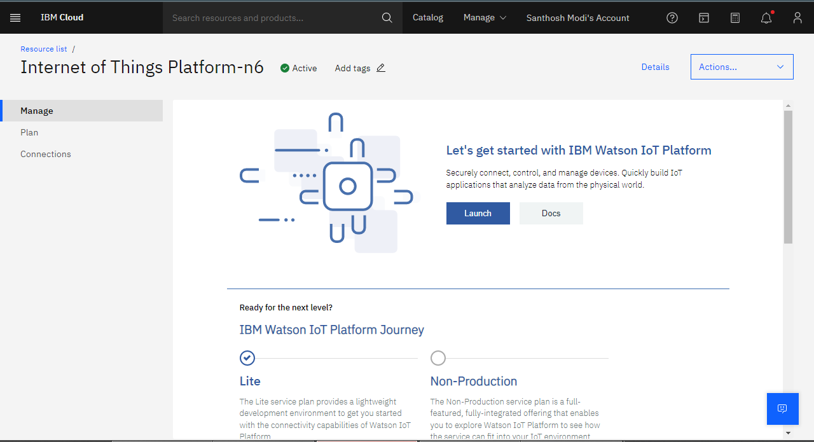

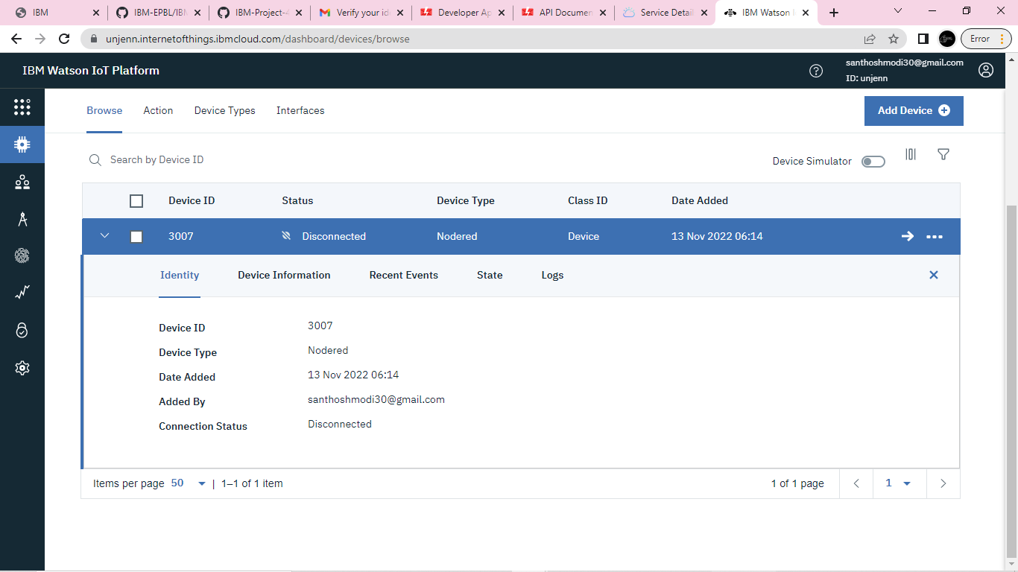

Device simulation is functional:

